**Business Case Study – Staff Planning**

**Problem Introduction**

The insurance approval process, i.e., underwriting is one of the important and time-consuming tasks in an insurance application processing. When you submit your insurance application, the underwriter of the company evaluates it based on the details that you provide using a rule-based or an ML model and decides whether or not to approve your application. You can refer to this [link](https://www.policygenius.com/life-insurance/how-does-the-life-insurance-underwriting-process-work/) for a better understanding of the underwriting process though it is not pertinent to the case study.

An insurance company InsurePlus wants you to help them with finding the optimal number of staff that they need for their insurance application approval process for the calendar year 2021.  In the industry, the number of staffs is considered as a continuous variable. This is also called a Full-Time Equivalent (FTE) of the staff. For example, if a full-time employee (FTE =1) works for 50 hours a week, 10 hours corresponds to 0.2 FTEs. If the pay for 50 hours a week is $5000, then 0.2 FTE who may be a part-time employee will be paid $1000 (5000*0.2). You can read about the concept of a full-time equivalent [here](https://www.shrm.org/resourcesandtools/tools-and-samples/hr-qa/pages/calculateftehours.aspx). In this case study, you have been provided with the information that follows.

**Note: Go through each and every point carefully to not miss out on any information.**

**Problem statement & background**

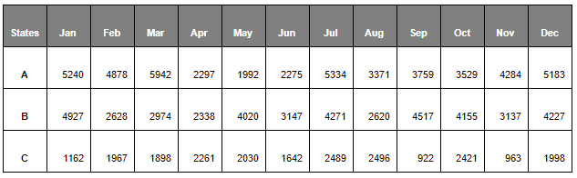The company operates in three states: A, B and C. The state-wise demand for insurance for the year is shown in the table provided below:

* The company can either handle an application with the staff that they hire or outsource it to a vendor. Assume that there is no capacity limitation to outsourcing.
* If they hire staff, he/she can handle 40 insurance applications per month when he/she works 100% of the workdays. However, there are days that he/she will be unavailable to process applications due to training, off days, etc.
* A staff member’s availability (in percentage) to work on processing the insurance applications for each month is shown in the table given below. As mentioned before, with 100% availability, each member can handle 40 applications.

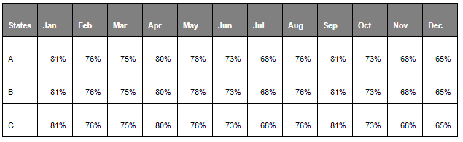

**A special note of practical relevance:**In the industry, staff availability is predicted using a time-motion study. But in this case, you have been given fixed numbers for each month in the table above. You can read more about the time-motion study [here](https://www.isixsigma.com/methodology/business-process-management-bpm/preparing-measure-process-work-time-study/) if you are curious but please note that it is not required to solve the case study.

* States A and B have a regulatory restriction that the outsourced insurance applications cannot be more than 30% and 40% of the total number of applications for each month, respectively.
* The table given below shows the cost of the staff vs external resources:

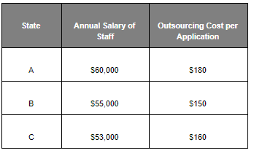

The objective is to optimise the total cost for the application approval process by distributing the right number of applications between the FTEs and the vendors while meeting the monthly demand for each state at the same time.

**Questions**

Now, based on the details provided, you need to answer the following questions given in the dropdowns. The title of the dropdown contains the questions and the dropdowns themselves contain some information relevant to the question.

arrow

Q1. The company wants to know the optimised staffing recommendations for the business case described.  Write the mathematical model for the deterministic optimisation problem. Define and explain your decision variables, objective function and the constraint.

**Hint:**Use months of the year as the model timeline. Staff FTE (staff full-time equivalent) can be treated as a continuous variable.

arrow

Q2. Code the problem in Python using any optimisation package of your choice.

**Note:**Add comments to your code to explain each step.

arrow

Q3. The company also wants to know the staffing recommendations for the worst-case and best-case scenarios. As mentioned earlier, there are days that an employee will be unavailable to process applications due to training, off days, etc. This will affect employee availability.

Let’s say you have the data for the minimum and maximum availability of the employees for each month, as shown in the table given below.

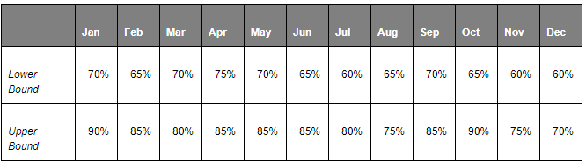

Assuming that the distribution is the same across all the states, answer the following questions:

* What is the optimal number of staff members for the worst and best cases?
* What are the percentages of outsourcing for the worst and best cases?
* What is the average cost per application for the worst and best cases?

arrow

Q4. Create the following visualisations using your preferred method (i.e. Python, PowerPoint, Excel, etc.) and add it to your report.

* Use the solution of Q2 to create a stacked column chart that shows the percentage of applications processed by the staff and by the vendor for each month (%staff processed applications + %vendor processed applications should add up to 100%).
* Create a graph to show how the cost per application increases with respect to any change in the parameters in your analysis. (**Hint:** Use the cost per application that you calculate in Questions 2 and 3, i.e., the actual scenario, best case, and worst case.)

The Excel workbook provided below contains the staff availability and the demand data that were mentioned earlier.

Download the stub file from the below attachment for writing your solution code.

**About the case study**

**Where do I get the data from?**

Read the data provided in the Excel workbook into Pandas dataframes and proceed with modelling.

**Where do I write the code?**

You have been provided with a stub file with an extract of questions. You need to fill in the code for each question. The commented cells provided are just placeholders. You are free to create additional cells/print any intermediate step results in the notebook.

**How do I submit the assignment?**

Once you are done with writing the codes in the stub file, the same file should be submitted in the **'submission'** segment.

**Some tips before starting the case study**

1. Make sure you have not made any changes to the original dataset provided to you. Your Python code should work on the dataset given to you as part of the problem statement.  During grading we will be running your code on the dataset provided by us, in case your code gives errors with that, then marks will be deducted accordingly.
2. In the notebook, read through each of the instructions carefully, identify the task to be performed, and only then proceed to write the required code. Don’t perform any incorrect analysis or look for information that isn’t required for the assignment. The solution output should be in the expected format if given in the question.
3. Try using appropriate aliases for the variable names. Avoid using names: ABC, abc, etc.
4. After solving for each scenario (subtask), create a dataframe that contains the results of that subtask. The dataframe should contain at least the state, month and the corresponding value of the decision variable(s) for each state-month combination. You can choose to have more columns of your interest in the dataframe, but the aforementioned columns are the minimum requirement. Mention the same in your final report as well along with the answers to for each task/subtasks.
5. You have been provided with checkpoints in your stub file to make sure you are going in the right direction.
6. You can also write the dataframes created at the end of each task into Excel worksheets. This will help you in creating charts as part of task 4.
7. For question 2, use the **average staff availability** (StaffAvPer) value. For question 3, use the upper bound (UB) and lower bound (LB) values of the staff availability.
8. You can refer to the solution of the practice problem of the module 'Operations Research-II', to understand how to read the data, process the data and write the optimisation results into an Excel workbook.
9. For questions 1 and 4, it is not compulsory to show the answers in the notebook. You can directly make the answers as a part of your report file.

**Submissions required**

1. **Jupyter notebook File:**The stub file given with the final codes (answers) written in it. This will be your solution file.
2. **Report file:**For all the six tasks, the results (dataframe, any specific results) should be well documented along with the insights for each task results. Save this document as a PDF.

Put both these files in a zip folder and submit the final zipped file in the 'Submission' segment.